RAIN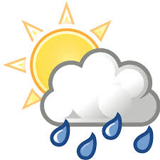
Rainfall in Toft is recorded with an official Met Office rain gauge. The measurement is taken at 9.00am GMT every day, and the amount for that 24 hour period is attributed to the previous calendar day. This data goes initially to the Environment Agency and then onwards to the Met Office.
July 2020
Date | Amount (mm) | Date | Amount (mm) | Date | Amount (mm) | Date | Amount (mm)
1 | 0.8 | 9 | 4.8 | 17 | 0 | 25 | 7.3
2 | 3.5 | 10 | Tr | 18 | 4.7 | 26 | 4.1
3 | 0 | 11 | 0 | 19 | 0 | 27 | 1.9
4 | 0 | 12 | 0 | 20 | 0 | 28 | 0
5 | 0 | 13 | 7.4 | 21 | 0 | 29 | 0
6 | 0 | 14 | 0 | 22 | 0 | 30 | 0
7 | 7.1 | 15 | 0 | 23 | 0.3 | 31 | 0
8 | 6.4 | 16 | 0 | 24 | 0
Tr = trace, too small to measure.

