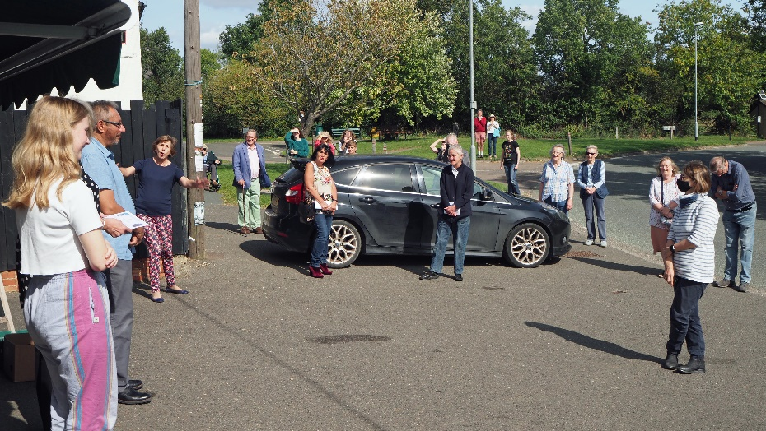
A grateful village said thank-you to our local shopkeepers, Justin and Jenny Orange on Saturday 12 September 2020 for their tireless service during the pandemic, maintaining supplies and deliveries and keeping everyone’s spirits up. Esther Wrycroft, one of the army of young volunteers who have staffed the shop during the lockdown, presented Justin and Jenny with a cheque for £2,200, made up of donations from customers.
Social distancing had to maintained
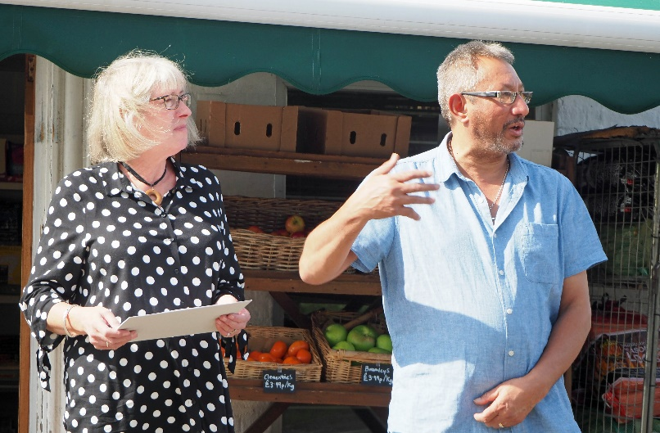  Justin and Jenny Orange: Justin here thanking everyone | 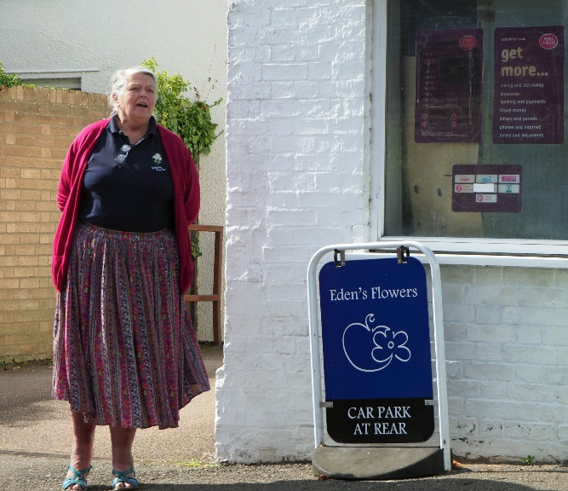  Ann Mitchell gave the thank-you address
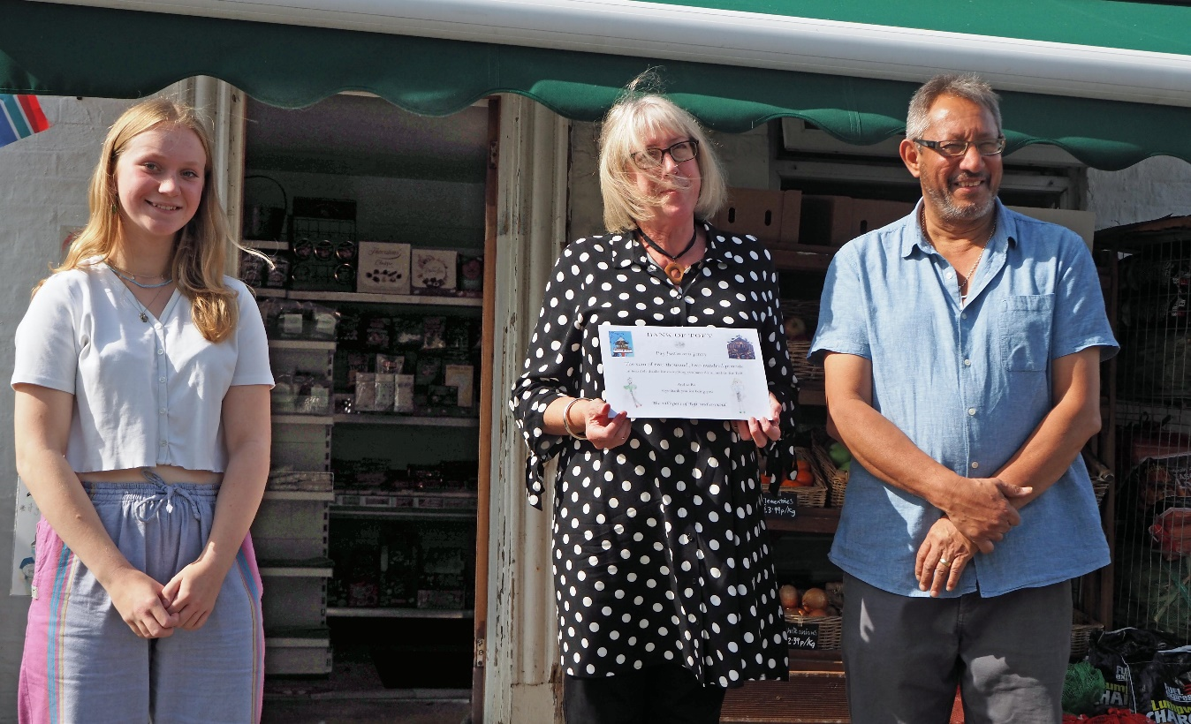
Esther Wrycroft presented the cheque
It was announced that there would be another opportunity to thank Justin and Jenny as the village gathers for Harvest Thanksgiving in the churchyard of Saint Andrew’s church on Sunday 4 October 2020 (weather permitting).

