RAIN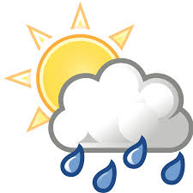
Rainfall in Toft is recorded with an official Met Office rain gauge. The measurement is taken at 9.00am GMT every day, and the amount for that 24 hour period is attributed to the previous calendar day. This data goes initially to the Environment Agency and then onwards to the Met Office.
The total for January 2020 was 46.9mm, compared to the January average over the previous 27 years of 51.0mm, with the daily amounts being as shown below:
Date | Amount (mm) | Date | Amount (mm) | Date | Amount (mm) | Date | Amount (mm)
1 | ) | 9 | 7.8 | 17 | 0.8 | 25 | 0
2 | ) | 10 | 0 | 18 | 0 | 26 | 1.9
3 | ) | 11 | 0.2 | 19 | 0 | 27 | 3.9
4 | 8.0 | 12 | 0 | 20 | 0 | 28 | Tr
5 | 0.1 | 13 | 3.7 | 21 | Tr | 29 | 0
6 | Tr | 14 | 8.6 | 22 | 0.2 | 30 | 0
7 | 0 | 15 | 0.6 | 23 | 0.3 | 31 | 0
8 | 3.8 | 16 | 7.0 | 24 | Tr
) = Amounts included in the next gauge reading.
Tr = trace, too small to measure.

