RAIN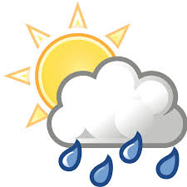
Rainfall in Toft is recorded with an official Met Office rain gauge. The measurement is taken at 9.00am GMT every day, and the amount for that 24 hour period is attributed to the previous calendar day. This data goes initially to the Environment Agency and then onwards to the Met Office.
August 2020
The month of August is, on average, one of the wetter months of the year. This year we had rain on 13 days, and the total was 167% of the long term average, resulting in it being the third wettest August in the last 27 years. Significant large daily amounts were recorded on 5 occasions, the largest being 18.5mm.
The total for the month was 95.8mm, compared to the July average of 57.4mm over the previous 27 years. The year to date is now virtually on a par with the average, being 364.6mm and 372.6mm respectively.
The daily amounts are shown in the attached table below:
Date | Amount (mm) | Date | Amount (mm) | Date | Amount (mm) | Date | Amount (mm)
1 | 0 | 9 | 0 | 17 | 1.4 | 25 | 0
2 | 0 | 10 | 0.3 | 18 | 0 | 26 | 0
3 | 0 | 11 | 0.2 | 19 | 4.8 | 27 | 8.4
4 | 0 | 12 | 0 | 20 | 0 | 28 | 14.9
5 | 0 | 13 | 15.4 | 21 | 0 | 29 | 2.3
6 | 0 | 14 | 0.9 | 22 | 0 | 30 | 0
7 | 0 | 15 | 9.8 | 23 | 7.2 | 31 | 0
8 | 0 | 16 | 18.5 | 24 | 11.7
Tr = trace, too small to measure.

