RAIN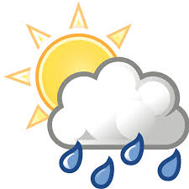
Rainfall in Toft is recorded with an official Met Office rain gauge. The measurement is taken at 9.00am GMT every day, and the amount for that 24 hour period is attributed to the previous calendar day. This data goes initially to the Environment Agency and then onwards to the Met Office.
October 2020
This was a wet month, the rainfall total being 116.0mm. This was 90% greater than the average over the past 28 years of 61.1mm. We had rain on almost every day, with significant amounts on at least 4 occasions.
The year to date is now a bit wetter than average, being 530.6mm and 488.4mm respectively.
The daily amounts are shown in the table below:

Date | Amount (mm) | Date | Amount (mm) | Date | Amount (mm) | Date | Amount (mm)
1 | 2.7 | 9 | ) | 17 | 0.7 | 25 | 2.7
2 | 10.5 | 10 | ) | 18 | 0 | 26 | 3.3
3 | 15.0 | 11 | ) | 19 | Tr | 27 | 2.1
4 | 3.8 | 12 | 20.4 | 20 | 4.8 | 28 | 3.3
5 | 2.2 | 13 | 0 | 21 | 9.3 | 29 | 3.6
6 | ) | 14 | 2.3 | 22 | 0 | 30 | 0.8
7 | ) | 15 | 3.2 | 23 | 4.3 | 31 | 6.2
8 | ) | 16 | 0 | 24 | 14.8
Tr = trace, too small to measure.
) = Gauge not read that day and amount accumulated to the next reading.

