RAIN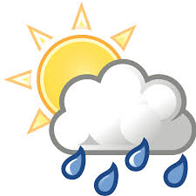
Rainfall in Toft is recorded with an official Met Office rain gauge. The measurement is taken at 9.00am GMT every day, and the amount for that 24 hour period is attributed to the previous calendar day. This data goes initially to the Environment Agency and then onwards to the Met Office.
November 2020
This was a dry month, the rainfall total being 27.3mm. This was less than half the November average over the past 28 years of 56.7mm. We only had rainfall of a significant amount on 2 days.
The year to date is now a bit wetter than average, being 557.9mm and 544.1mm respectively.
The daily amounts are shown in the table below:

Date | Amount (mm) | Date | Amount (mm) | Date | Amount (mm) | Date | Amount (mm)
1 | 0.2 | 9 | 2.2 | 17 | 0 | 25 | 0.2
2 | 8.0 | 10 | 0 | 18 | 0.1 | 26 | 0.1
3 | 0.1 | 11 | 2.0 | 19 | 0.2 | 27 | Tr
4 | ) | 12 | 0.1 | 20 | 1.0 | 28 | 0
5 | ) | 13 | 0.6 | 21 | 0.2 | 29 | 0
6 | ) | 14 | 9.9 | 22 | Tr | 30 | 1.1
7 | ) | 15 | 0.4 | 23 | 0
8 | 0.6 | 16 | 0.3 | 24 | 0
Tr = trace, too small to measure.
) = Gauge not read that day and amount accumulated to the next reading.

