RAIN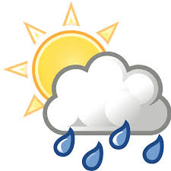
Rainfall in Toft is recorded with an official Met Office rain gauge. The measurement is taken at 9.00am GMT every day, and the amount for that 24 hour period is attributed to the previous calendar day. This data goes initially to the Environment Agency and then onwards to the Met Office.
December 2020
This was a wet month with 117.5mm of rain. This is more than twice the average for December of 52.5. This excess was accounted for by more than 25mm on each of two separate days. On the morning of the 4th we had a thin covering of snow.
The daily amounts are shown in the table below:

Date | Amount (mm) | Date | Amount (mm) | Date | Amount (mm) | Date | Amount (mm)
1 | 0 | 9 | 0.2 | 17 | 0.2 | 25 | 0
2 | 1.9 | 10 | 6.5 | 18 | 0.2 | 26 | 3.6
3 | 27.9 | 11 | 0.8 | 19 | 0.4 | 27 | 0.1
4 | 3.5 | 12 | 3.2 | 20 | 5.1 | 28 | 0.7
5 | 0.1 | 13 | 13.5 | 21 | 6.4 | 29 | Tr
6 | Tr | 14 | 0 | 22 | 2.5 | 30 | Tr
7 | Tr | 15 | 0 | 23 | 28.2 | 31 | 0
8 | 8.5 | 16 | 4.0 | 24 | 0
Tr = trace, too small to measure.
Full year 2020
The total rainfall for the year was 675.4mm making it significantly wetter than the average over the past 28 years of 594.8mm. Only 5years have been wetter than 2020.

