Agriculture in Toft – Past and Present  A contribution to Toft 2020 | 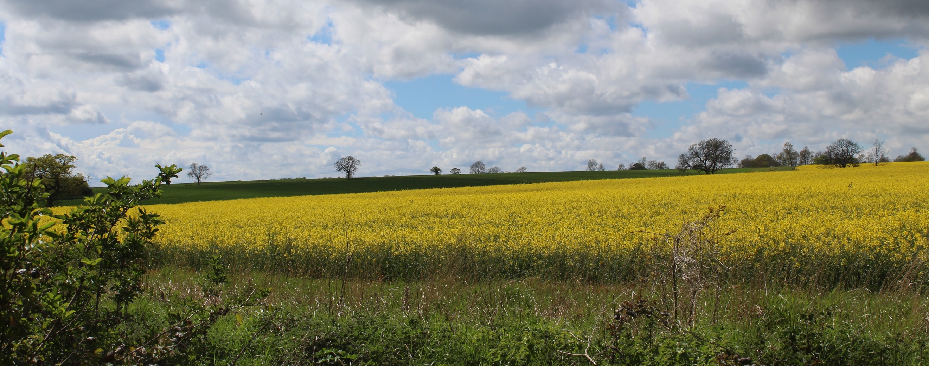

Agriculture in the Bourn Valley is currently dominated by arable farming though there are also areas of grazing land, particularly in proximity to the Bourn Brook where flooding has always been an issue for intensive crop production.

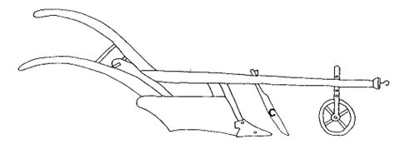
The heavy clay soils that characterise the flanks of the Bourn Valley are nutrient rich but in Roman and Romano-British times these soils were impractical to plough effectively and so most crop growing would have been restricted to the lower slopes of the Valley where soils were more workable and small-scale strip farming was possible. The upper slopes of the Bourn Valley would have been used primarily for grazing.
The invention of the Heavy Plough around 1000 BC and its gradual introduction had transformed Northern European agriculture by the Medieval period. It required a big team of oxen/horses but these could be shared within a village. It allowed deep ploughing of heavy soils which turned the soil more effectively and allowed for both better weed control on heavy soil in damp climates as well as the incorporation of crop residues, green manure, animal manure or other substances into the soil. This in turn allowed the development of the Medieval open field system, provided better field drainage, and yielded better harvests.
In Toft the open field system involved two large fields - the East Field and the West Field – and farming these fields at that time would have involved virtually everyone living in Toft to some degree. The open fields were very large areas of land sub-divided into furlongs, which were then further subdivided into strips, and access tracks (Commons) such as Lot Way, Mill Way, Wood Way (see below). The typical planting scheme was a three-field system where barley, oats or legumes would be planted in one field in spring, wheat or rye in the second field in the fall and the third field would be left fallow. The following year, the planting in the fields would be rotated. The tenants pastured their livestock on fallow field areas and on planted fields after harvest. With only two open fields in Toft there must have been some subdivision of the two fields for three field rotation to be implemented. The old names of certain fields (Parson’s Meadow, Lord’s Meadow) indicate their primary use for grazing. Fields prone to flooding near Bourn Brook would have been mainly pasture land.
The Heavy Plough

Lot Way  Wood Way  Mill Way  Parson’s Meadow  & Lord’s Meadow  OPEN FIELD SYSTEM OF TOFT (1815 MAP)  Village area (mainly fields) | MODERN TOFT PARISH  Map: J. Tebbit
The rise of capitalism and the concept of land as a commodity to be bought and sold, especially after the 15th century, led to the gradual demise of the open-field system and the rise of private ownership of land, in a process known as inclosure (or enclosure) in England. However, Toft still had much of the framework of the open field system visible as late as the early 19th Century (see 1815 map on left).

The map (right) of modern Toft Parish shows the significant increase in land area given over to village housing, the Village College and, most significantly, the Meridian golf course. A recent further incursion into the agricultural area of Toft Parish is the Bennell Court development which is being built opposite the Village College.

Restrictions on the importation of food supplies during the two World Wars required an increase in arable farming capability to allow greater self-sufficiency. This led to greater mechanisation in farming practices (particularly after WWII) to improve productivity. Todays’ farmers have access to powerful machinery that can easily work large fields of heavy clay soil and generate very high productivity.

In contrast to the start of the 20th Century when farms still required substantial numbers of farm workers the modern farm operates with only a handful of farm workers. Rural villages are no longer dominated by agriculture and the industrial scale intensive farming seen in this area utilises mechanisation, biotechnology, satellite navigation and sophisticated chemical and biological tools to optimise crop productivity.

The main crops before Enclosure were much the same as today – wheat and barley and, to a lesser extent, legumes. However, nowadays there is also a large market for plant oils and, more recently, for biofuels. Oilseed rape is a very popular cash crop and its yellow flowers are very commonly seen in the Toft spring landscape. Linseed and sunflowers are also grown for their oils which, like oilseed rape, have a range of uses.

The area of farmland around Toft that once encompassed the West Field has been walked (Left, in yellow) by Toft villagers each May during the Village Spring Feast and, in recent years, the crops in these fields have been monitored by Toft Historical Society. In 2020 we were unable to have our annual Spring Feast village walk around the West Field but we nevertheless monitored the crops and these are recorded here. We also took the opportunity in 2020 to extend the study further to include the modern fields that cover the area of the medieval East Field.

The aerial image to the left shows the modern fields that overlie the old West Field area and some of the footpaths that mark the ancient common ways. The fields have been numbered for ease of location and these numbers link with the current field names (see tables below). Many of these are old names (such as Mill Field, Lousy Leys and Foxholes) dating back hundreds of years whilst others are of more recent origin (Barton Corner, Farrows and 44 Acres).

1
2
3
4
5
8
6
9
10
7
11
12
12a
13
14
11a
1a

This Pre-Enclosure map from 1815 indicates the two large Common fields dating back to medieval Toft. The coloured area shows the village and associated fields that made up a further Common Field.
Wood Way

Hardwick
Wood

Mill Way

Lot Way

Recent Crops in the West Field: 2016-2020

WEST FIELD
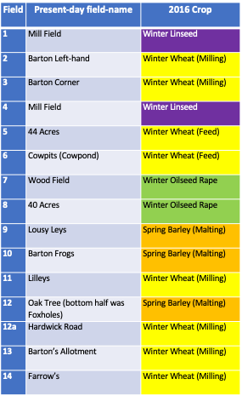
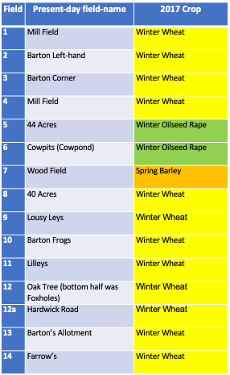

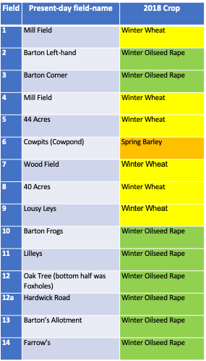
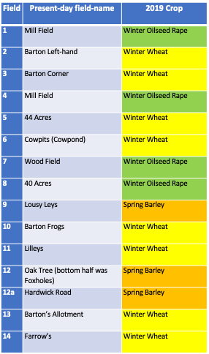
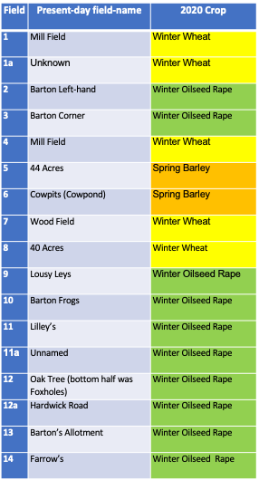

The 2020 Crop list for the Toft West Field was extended to include fields 1a and 11a to more fully represent the area of the original West Field. The five tables above illustrate the way in which farmers change the crops annually in each field and the amounts of each crop grown each year, which in part will reflect the market price. The extensive planting of Oilseed Rape in 2018 and 2020 is a notable departure from the crops grown in medieval Toft.
Wheat
Wheat
Wheat
Wheat
Wheat
Wheat
Wheat
Wheat
Wheat
Wheat
Wheat
Wheat
Rapeseed
Rapeseed
Barley
Barley
Rapeseed
Rapeseed
Rapeseed
Rapeseed
Wheat
Rapeseed
Grazing
Grazing
Grazing
Grazing
Toft Parish Crops 2020 – Both East and West Fields
This is an aerial photograph of Toft Parish to show the distribution of field crops and grazing areas in 2020. Both the West Field and the East Field areas are represented here. The aerial photograph and the map both indicate the substantial part of East Field lost to the Village College, the Golf Club and, housing developments at the eastern boundary.
WEST
FIELD
EAST FIELD

