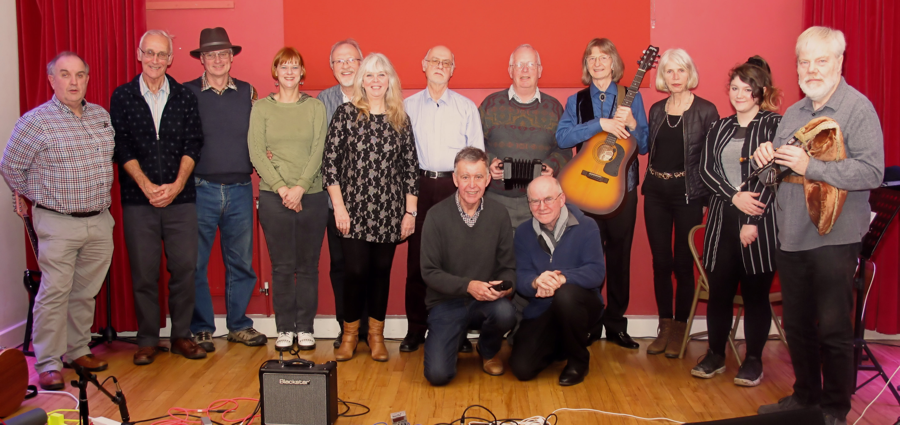
Musicians at the splendid Toft Open Mic Music Evening in Jan 2020.
From L to R
John (our sound man) Patrick, Ron, Katrina, Steve, Helen and Tim aka Silver Lining, Paul, Eric and Pat, Ellie and Mike.
In front Martin and Barney

